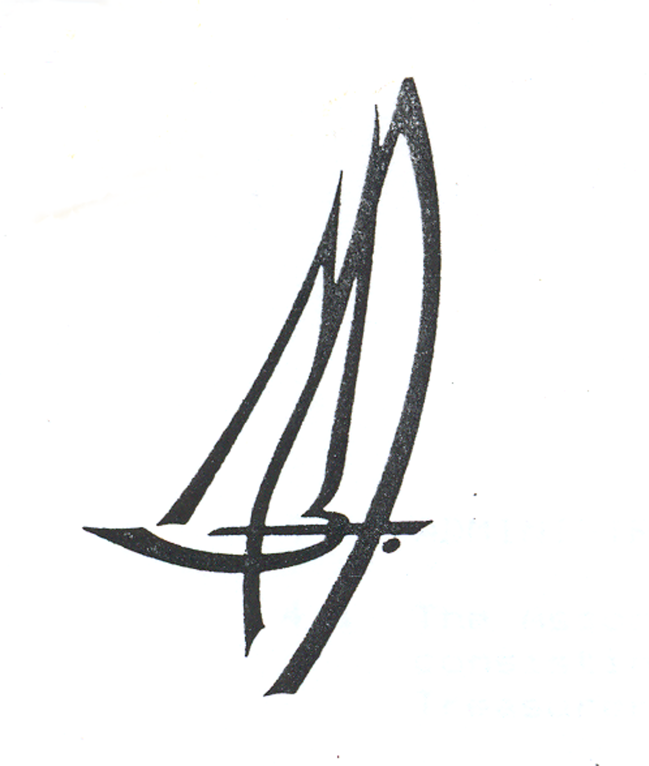

MMBA IOM Open National Championship

27th to 31st March 2009

To be held at the Ta ‘Xbiex Aquatic Water Centre, Msida, Malta.

Entry Form
Name
Address & Phone No

E-Mail Address
Boat Number
Design
Frequency – 6 frequencies – preferred frequency first

Entry Fee – 50 Euros
Cheques should to be made payable to ‘MMBA’ and forwarded to Mr Vinnie Zammit, Hon. Sec. MMBA
at 303, St Albert’s Street, Gzira, Malta, GZR 1151
Or
Payment by cash only, can be made at Registration on either Friday 27th March or Saturday 28th March.

Please note that early entries would be much appreciated.
Closing date for receipt of entries is Monday 23rd March.
Entries to be returned via E-mail to Vinnie.zammit@gmail.com or maltamba@gmail.com
Or to Mr Vinnie Zammit at address detailed above.

