 | International One Metre

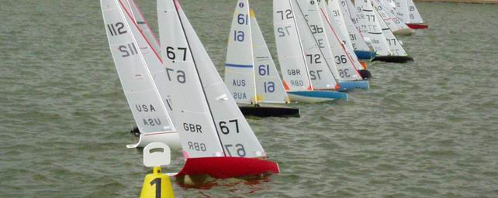

The class
The three permitted rigs are one-design, while the hull and appendages are open to development. Displacement is 4 kg, LOA 1000 mm, and draft 420 mm. An IOM sails in winds up to 35 knots. There are kits available from manufacturers in North America, Europe, and Oceania, and several manufacturers can also deliver complete boats ready for racing. The IOM ICA estimates around 15,000 IOM owners worldwide, and the class is raced in almost every country where there are radio sailors. There is a flourishing second-hand market in well-cared-for IOMs, which have a long competitive life and maintain their value well.

Championships
International championships are staged each year, Worlds and Europeans alternating, each attracting a maximum entry. The Royal Vancouver Yacht Club staged the 2003 Worlds as part of their centenary celebrations, with the participation of sailors from 16 countries.

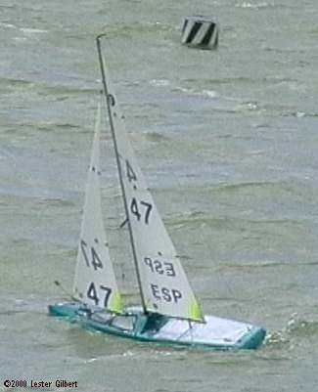

Racing
Racing takes place under the RRS and Appendix E. For a given “race”, the fleet of up to 80 boats is divided into “heats” of up to 20 boats. Heats are run in reverse order, with the top four boats in a heat being immediately promoted to race in the next higher heat. The bottom four boats are relegated and sail in the lower heat in the next race. When all heats of the race are sailed, the boats are scored in order, from the winner of “A” heat down to the last boat in the lowest heat. The next race then sails, starting with the lowest heat.
Achieving success in IOM racing is a considerable challenge, needing a good grasp of how a boat works, detailed attention to equipment preparation, practice with tuning the boat, and all of the usual racing skills of strategy, tactics, and reading the wind. Because the boats are so closely matched in performance and the competitors have a very good view over the whole heat, racing is intensely tactical, “a game of chess on the water”.
International events, typically involving six racing days, have recently become umpired, ideally suited to the fast-paced racing, where up to 30 heats can be sailed in one day. Judges and competitors alike are enthusiastic about the opportunities to successfully manage so much close racing in every day of an event.

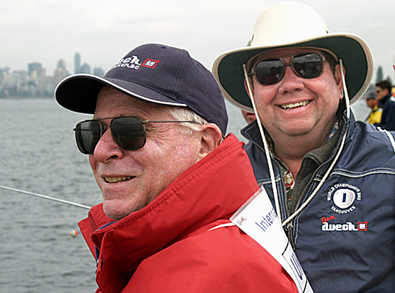

Class association
The IOM International Class Association (IOMICA) is responsible for the class under the jurisdiction of the ISAF Radio Sailing Division.

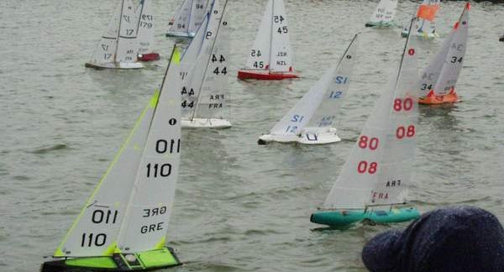
http://www.iomclass.org
IOMICA Chairman: chairman@iomclass.org | IOMICA Secretary: secretary@iomclass.org

