IOM Class Rule amendments – alignment of the IOM Class Rules with the 2025 version of the of the Memorandum of Understanding between IRSA and IOM ICA

Current status
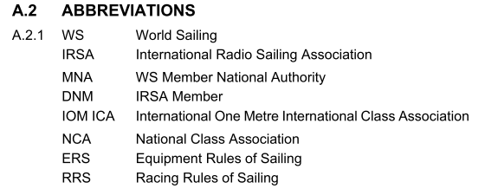
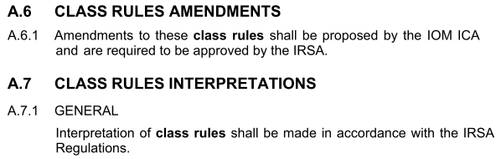

Proposals
- Add following in A.2.1:
MoU Memorandum of Understanding made between the IRSA and the IOM ICA

- Replace A.3.1 with following:
A.3.1 IRSA recognises IOMICA as the International Class Association for the International One Metre Class with responsibilities for the Class Rules.

- Replace A.6.1 with:
A.6.1 Amendments to these class rules shall be done by the IOM ICA in accordance with the MoU between IRSA and IOM ICA.

- Replace A.7.1 with:
A.7.1 Interpretation of class rules shall be made by the IOM ICA in accordance with the MoU between IRSA and IOM ICA.

Reasons
Above mentioned amendments of the IOM Class Rules are needed because of the Item 5.2(e ) of the 2025 version of the Memorandum of Understanding between IRSA and IOM ICA containing following:
5.2(e) IOMICA shall be responsible for administering the International One Metre Class Rules and technical or measurement questions as they relate to the International One Metre Class. IOM Class Rule interpretation and amendments shall be done by the IOM ICA in accordance with IOM ICA Regulations. Formal approval of interpretations and amendments by the IRSA as mentioned in the IRSA Regulation shall comprise checking the proper use of the World Sailing Standard Class Rules format and Equipment Rules of Sailing only. IRSA shall be allowed to post their comments on the IOMICA website and speciﬁc section of IOMICA forum (on the same schedule as the NCA’s but without voting rights), to share IRSA’s opinions on the proposed rule with the IOMICA membership

IOM ICA VC Technical proposed resolution for 2025 IOM ICA AGM
4 September 2025

