IOM ICA Regulations amendments – alignment of the IOM ICA Regulations with the 2025 version of the of the Memorandum of Understanding between IRSA and IOM ICA

Current status
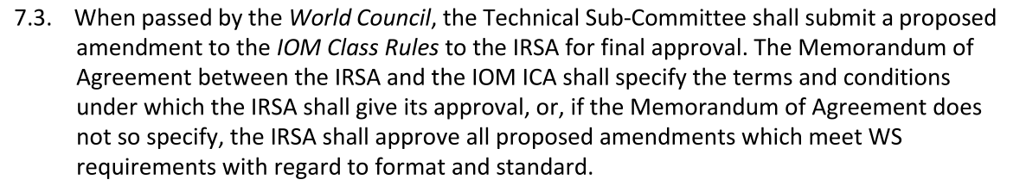
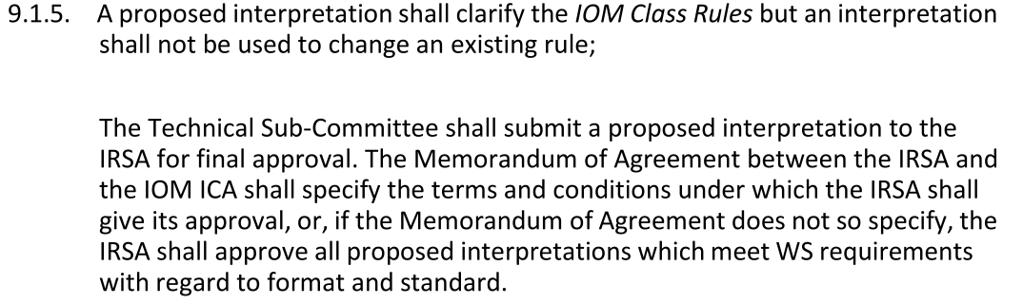
Proposals
- Replace 7.3 with:
IOM Class Rules amendments shall be done by the IOM ICA Technical Sub-Committee in accordance with IOM ICA Regulations. Formal approval of amendments by the IRSA shall comprise checking the proper use of the World Sailing Standard Class Rules format and Equipment Rules of Sailing only. IRSA shall be allowed to post their comments on the IOMICA website and speciﬁc section of IOMICA forum (on the same schedule as the NCA’s but without voting rights), to share IRSA’s opinions on the proposed rule with the IOMICA membership.

- Replace a second paragraph in 9.1.5. with following:
IOM Class Rules amendments shall be done by the IOM ICA Technical Sub-Committee in accordance with IOM ICA Regulations. Formal approval of interpretations by the IRSA shall comprise checking the proper use of the World Sailing Standard Class Rules format and Equipment Rules of Sailing only. IRSA shall be allowed to post their comments on the IOMICA website and speciﬁc section of IOMICA forum (on the same schedule as the NCA’s but without voting rights), to share IRSA’s opinions on the proposed rule with the IOMICA membership.

Reasons
Above mentioned amendments of the IOM Class Rules are needed because of the Item 5.2(e ) of the 2025 version of the Memorandum of Understanding between IRSA and IOM ICA containing following:
5.2(e) IOMICA shall be responsible for administering the International One Metre Class Rules and technical or measurement questions as they relate to the International One Metre Class. IOM Class Rule interpretation and amendments shall be done by the IOM ICA in accordance with IOM ICA Regulations. Formal approval of interpretations and amendments by the IRSA as mentioned in the IRSA Regulation shall comprise checking the proper use of the World Sailing Standard Class Rules format and Equipment Rules of Sailing only. IRSA shall be allowed to post their comments on the IOMICA website and speciﬁc section of IOMICA forum (on the same schedule as the NCA’s but without voting rights), to share IRSA’s opinions on the proposed rule with the IOMICA membership

IOM ICA VC Technical proposed resolution for 2025 IOM ICA AGM
9 September 2025

