USA NCA Resolution for IOM Class Rule amendment –
vang and associated fittings/openings on main boom

- Replacement of the term “kicking strap” with the term “vang”.
Current status
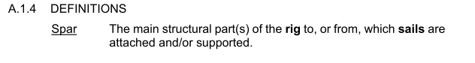
Proposal
Add following in A.1.4:
Vang Equipment connected to the boom and used to control the angle between the mast and the boom.

Replace the “kicking strap” with “vang” in the whole body of the IOM Class Rules

Reason
Term “kicking strap” is used in the IOM Class Rules. This is not ERS defined term.
The ERS 2025-2028 has the defined term vang. It includes Gnav variations which are not allowed in the IOM Class Rules. Therefore the modified definition should be added in the IOM Class Rule A.1.4

- Allowing more than one vang fitting and associated ‘Openings’ which will support tension adjustment along the main boom

Current status
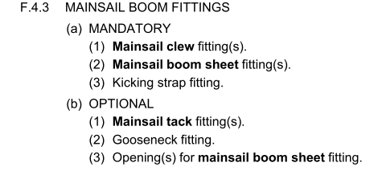

Proposal
F.4.3 MAINSAIL BOOM FITTINGS
(a) MANDATORY
(1) Mainsail clew fitting(s).
(2) Mainsail boom sheet fitting(s).
(3) Vang fitting(s).
(b) OPTIONAL
(1) Mainsail tack fitting(s).
(2) Gooseneck fitting.
(3) Opening(s) for mainsail boom sheet and vang fitting(s)

Reason
To allow more than one vang fitting and associated ‘Openings’ which will support tension adjustment along the main boom. This would support Class Rule F6.3 (b) and in accordance with the IOMICA website. Refer to Questions & Answers page / Rig / Questions related to the various mainsail boom kicking strap arrangements / Case 2.
Allowing simple vang arrangement as shown below:
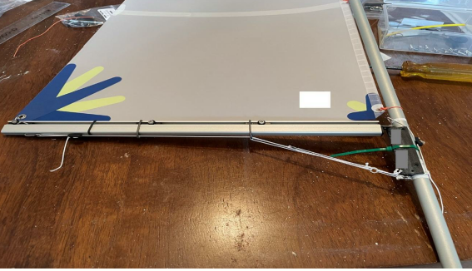

USA NCA, John Taylor, Registered Member
USA NCA Representative: Steve Landeau, IOM USA Vice Chair - Technical
11 September 2025

